11.4 Volume GP 1 All images captured at 110%

Hot tub

Pool



RADIUS



DIAMETER

HEIGHT





RADIUS

WIDTH

LENGTH

HEIGHT

HEIGHT

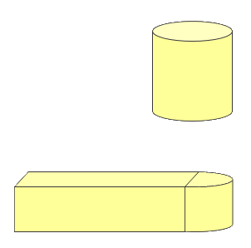

12 feet

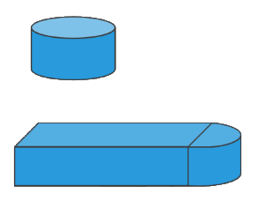

6 feet

HOT TUB

POOL

25 feet

12 feet

5 feet

5 feet

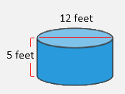

HOT TUB

Snipped from the white background and switched background in paint.net



FIRST FLOOR

12 feet

5 feet

5 feet

25 feet

6 feet





12 feet

12 feet

12 feet

6 feet

25 feet

5 feet

5 feet

